**Experiment 8**

Name: Ravish Dagar

Sap-500061767

Roll No-96

* Aim- Design a 3D car on blender.
* Procedure-

1. Open a new blender file.
2. Add a cube mesh.
3. Add a car background image for reference.

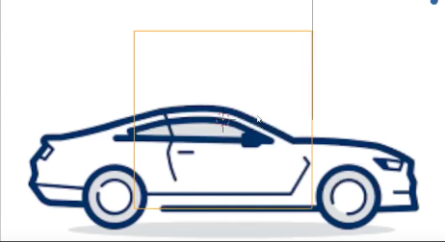

1. Sculpt the cube mesh according to the car image.
2. Sculpt the lower exterior of the car and give space for the car tire.
3. Finally, when the whole car is sculpted, add mirror modifier to the car.
4. For tires, add a mesh cylinder and sculpt it like a tire.
5. Add the tires to the car and duplicate it 3 times for other space as well.
6. Also add brake lights and front lights using mesh plane and mesh sphere respectively.
7. Sculpt the brake and front lights accordingly.
8. Paint the car with desired color.

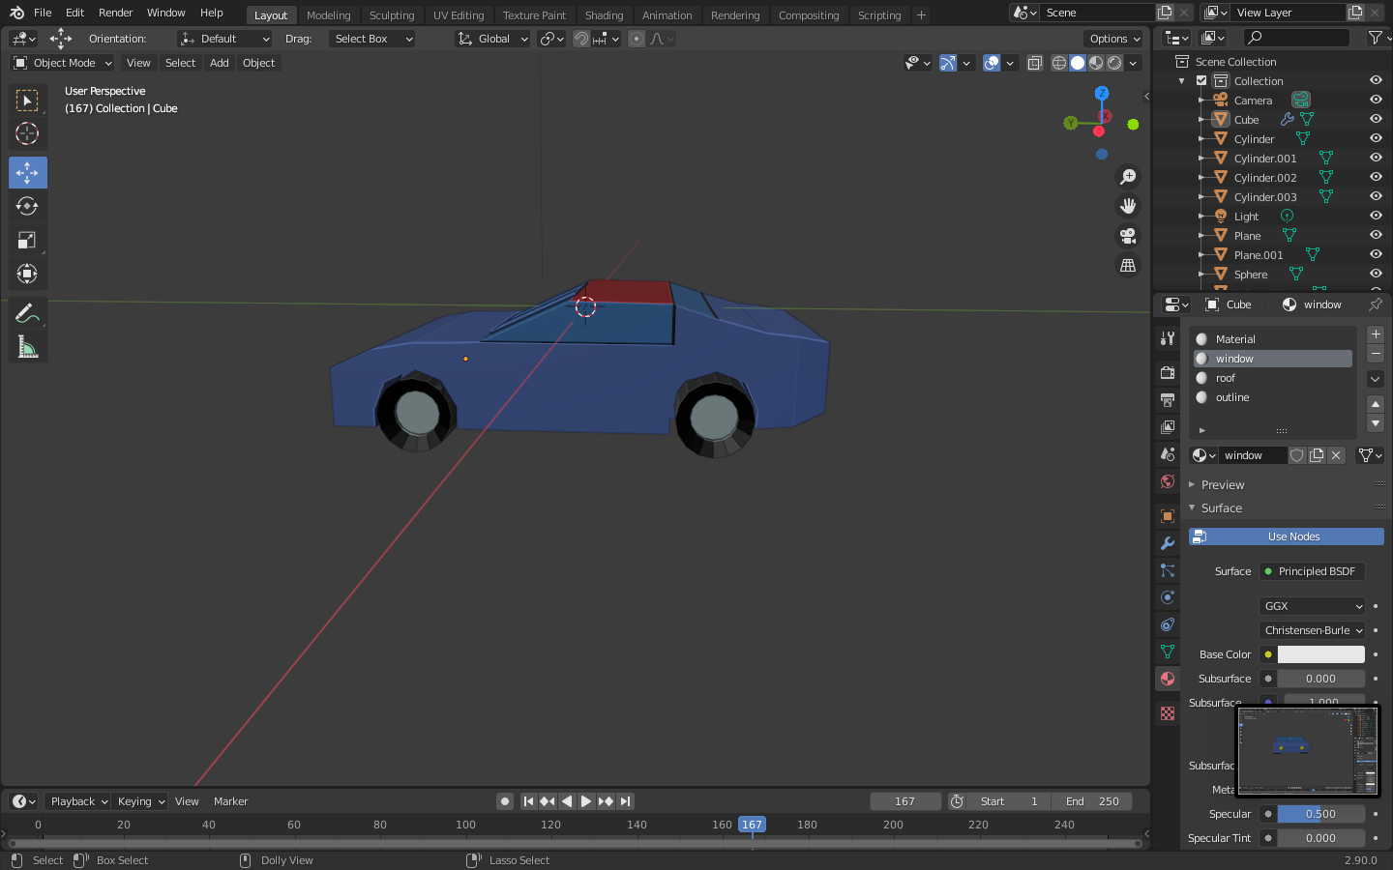

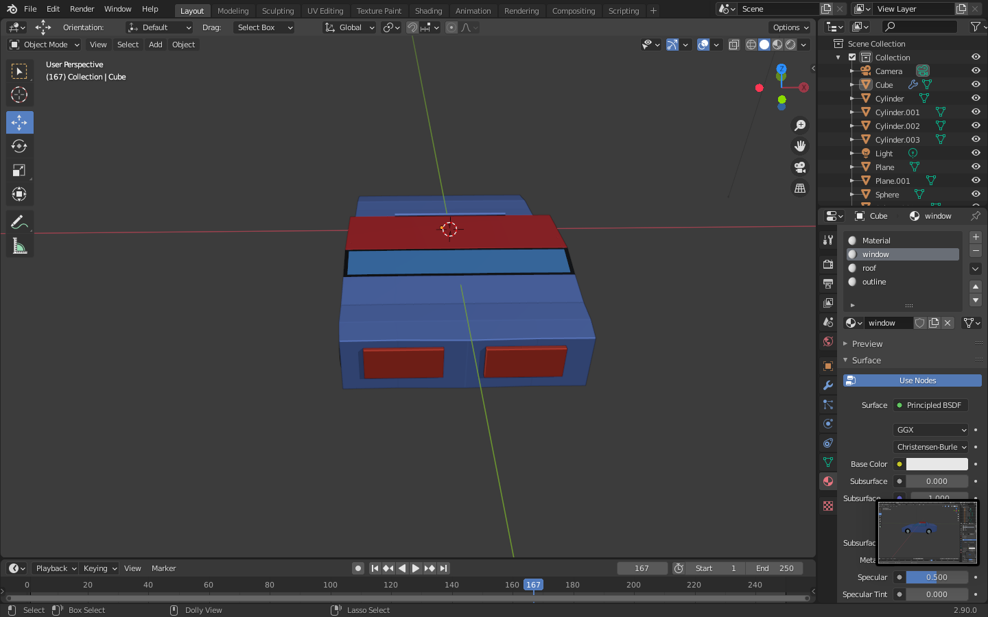

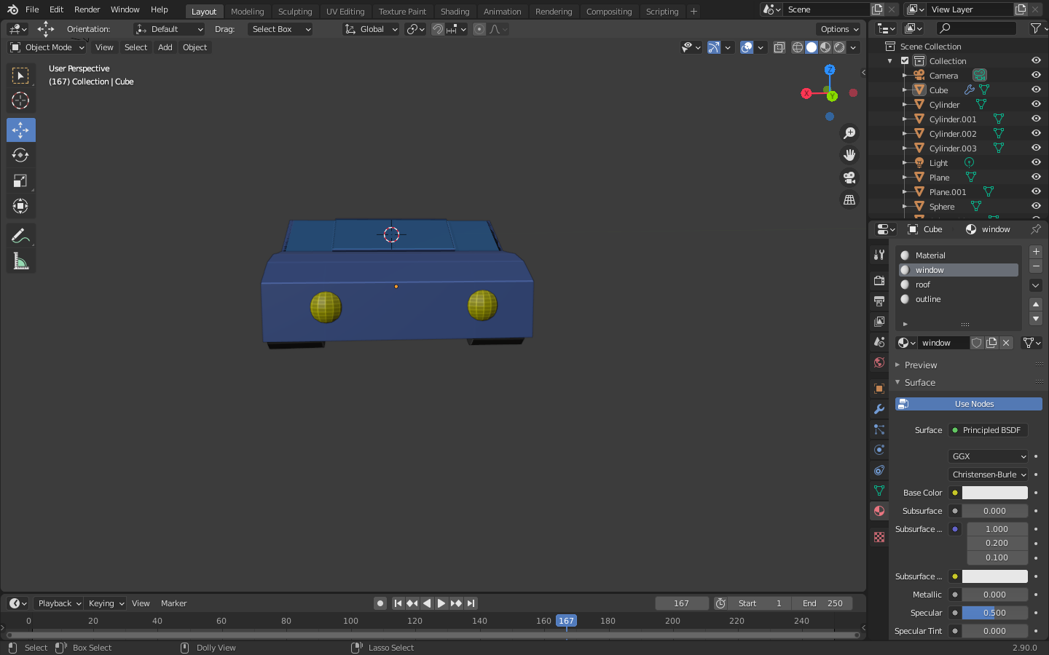

1. 3D car is completed.

